**Live Weather Report**

**28-Sept-2025 Ajmer Weather Report**

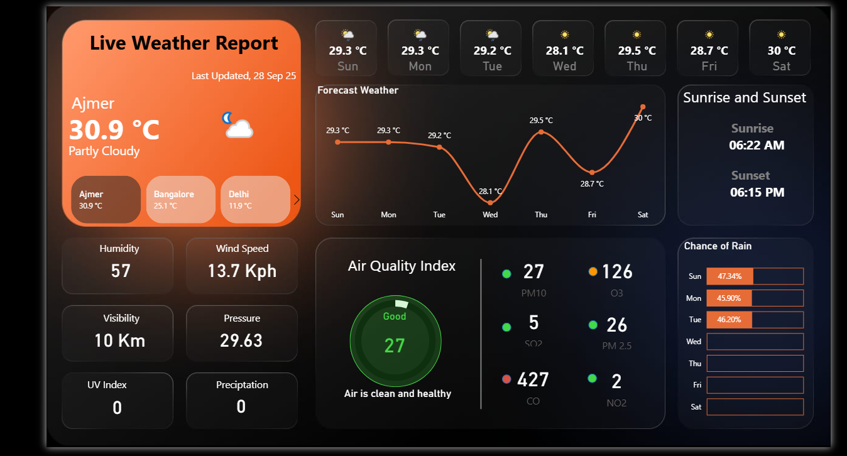

**29-Sept-2025 Ajmer Weather Report**

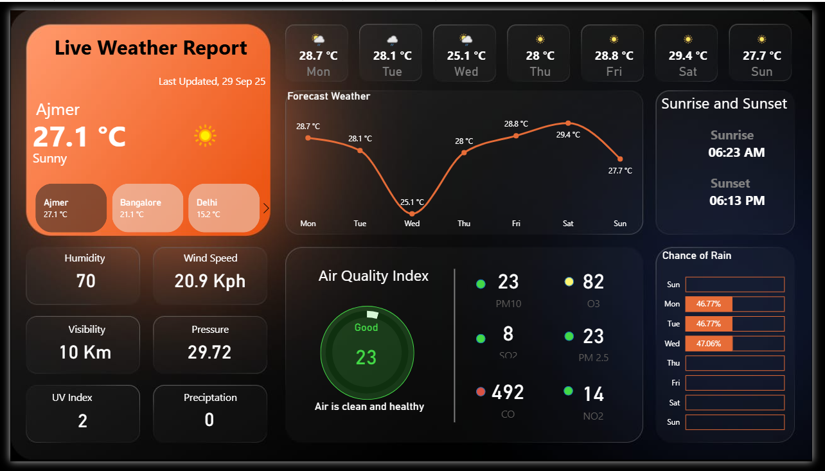

**29-Sept-2025 Bangalore Weather Report**

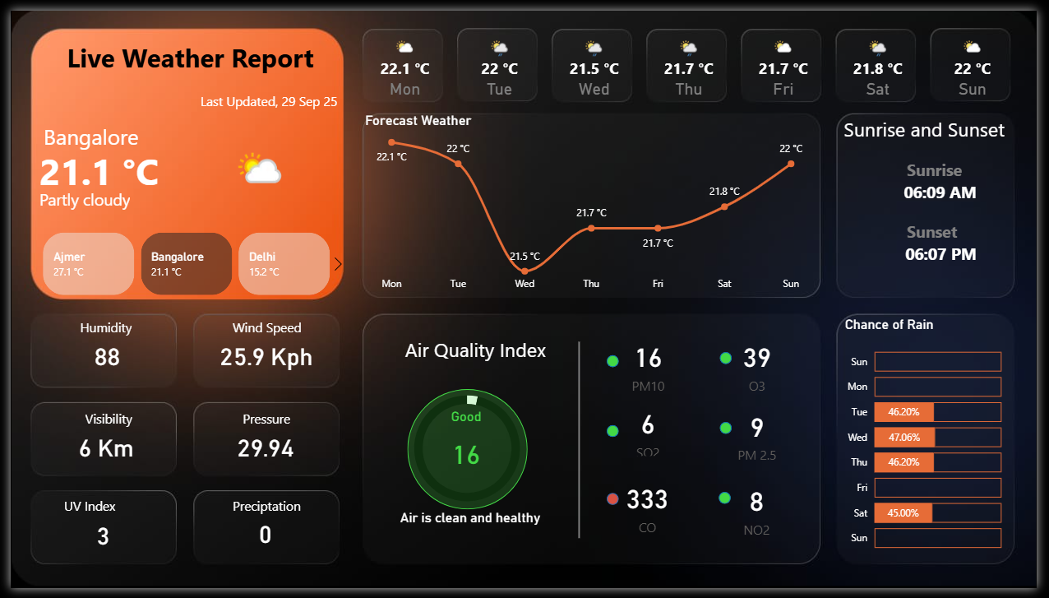

**29-Sept-2025 Mumbai Weather Report**

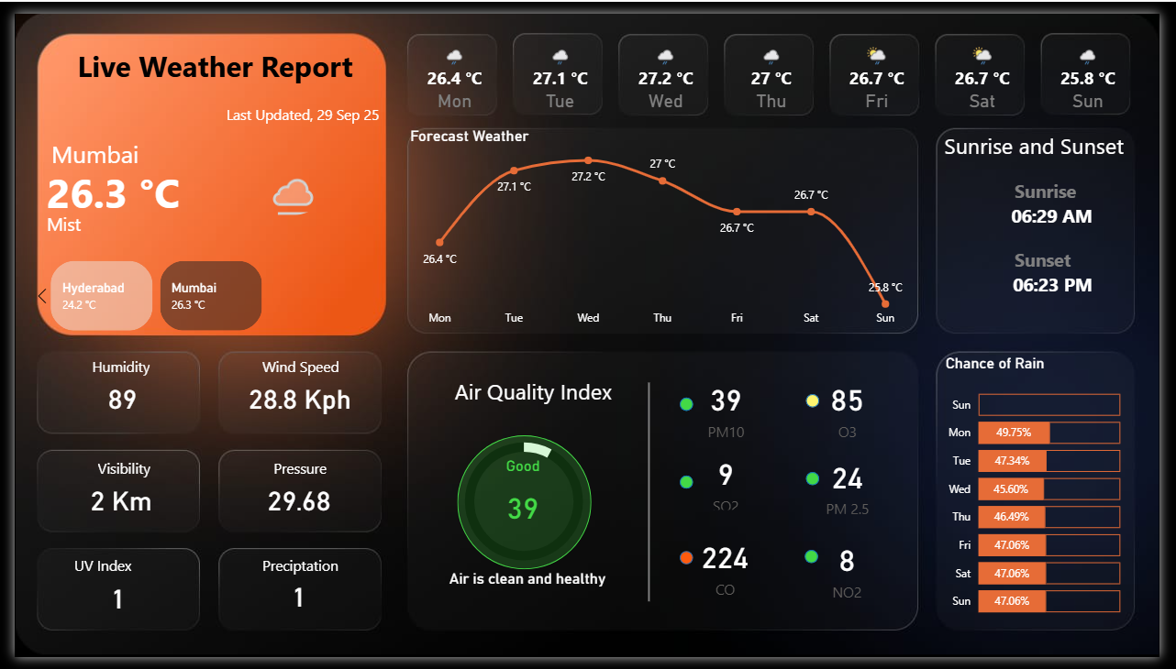

**29-Sept-2025 Hyderabad Weather Report**

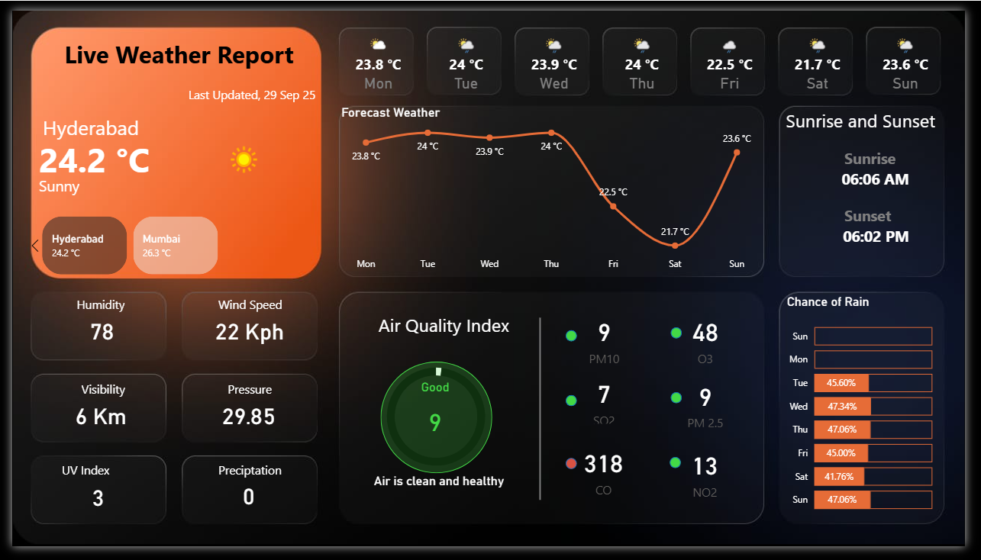

**Measures and Tables used**

